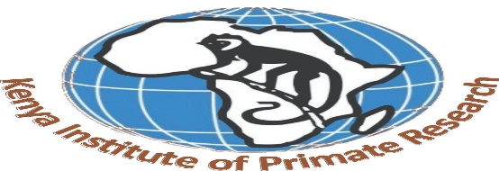

INTERNAL MEMO

REF: KIPRE/HR/06/19901899045
DATE: 24th June 2025
TO: Ag Head Human Resource and Administration.
From: Human Resource Officer

RE: PAYMENT OF ALLOWANCES FOR THE DIRECTOR GENERAL.
Kindly approve the payment of the difference of the under payment of allowance for the Director General as per the Memorandum approved by the chairman of the Board of Directors Kenya Institute of Primate Research Dated 13th May 2025 on payment of allowances as guided by salaries and Renumeration commission, Public Service Commission, State corporation Advisory Committee and KIPRE Human Resource and Procedure Manual.
Please Consider the Harmonization of allowances Applicable to Job Group T Circular from the Ministry of State for Public Service REF: DPM/38/1/1A Dated 10th April 2007(attached).
Allowances | Current | CIRCULAR: DPM/38/1/1A PAY | Total difference payable | Arrears from 1st September2024-june2025(10 months)
Entertainment Allowance | 20,000 | 65,000 | 45,000 | 450,000
Extraneous/Responsibility allowance | 40,000 | 60,000 | 20,000 | 200,000
Domestic Allowance | - | 15,600 | 15,600 | 156,000
Air Time Allowance | 5000 | 6000 | 1000 | 10,000
Total payment |  |  |  | 816,000

Thank You.

